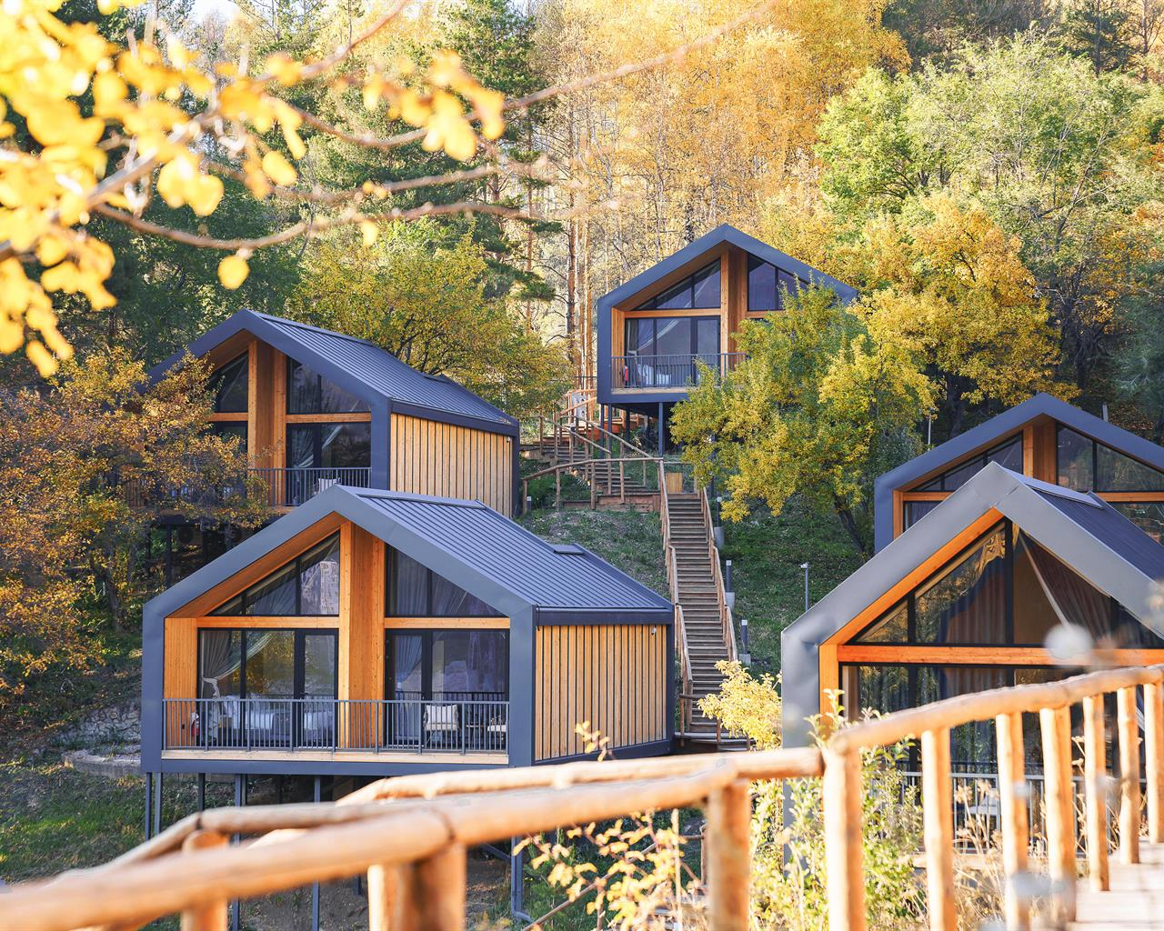
Immerse in the ultimate blend of luxury and tranquillity: enjoy glamorous glamping in the serene mountains and lavish stays in vibrant Almaty, offering the perfect balance of nature and city life.
4 NIGHTS ALMATY (Qazaq Ayul Glamp + With Ritz Carlton)
ITINERARY AT A GLANCE
DAY 1  - Welcome to Almaty  - Meet & greet with your guide.  - Transfer to Qazal Ayul luxury glamping.  - Check-in to the mountain glamp for breathtaking views, luxurious Villa, and serene mountain tranquillity. | DAY 2  - Breakfast & Check-out formalities.  - Excursion to Shymbulak  - Quick stop at scenic Bellagio restaurant for a photo op.  - Discover Panfilov Park & Zenkov Cathedral  - Check-in to Ritz Carlton  - Dinner as per choice.  - Night out in Almaty: Explore vibrant bars and nightlife hotspots. | DAY 3  - Breakfast with a view  - Issyk Lake- Discover stunning alpine scenery and crystal-clear waters.  - Kok Tobe: Serene sunset with breathtaking city views.  - Dinner as per choice
DAY 4  - Breakfast with a view  - Green Bazaar: Vibrant local market experience with diverse foods and crafts.  - Shopping.  - Dinner as per choice. |  | DAY 5  - Breakfast with a view  - Check-out formalities.  - Farewell: Enjoy the final city views as we head to the airport.

PRICE GRID (Non-Visa Countries-2024) Validity (19th April – 30th December)

4N  Luxurious Almaty | Ritz Carlton + Qazaq Ayul  (Low Season) | Ritz Carlton + Qazaq Ayul  (High Season)
 | 5 ***** | 5 *****
2 Pax | U$ 1230 | U$ 1365
4 Pax | U$ 1106 | U$ 1240
6 Pax | U$ 1040 | U$ 1174
8 Pax | U$ 1006 | U$ 1140
10 Pax | U$ 1018 | U$ 1154
12 Pax | U$ 1000 | U$ 1135
14 Pax | U$ 986 | U$ 1120
16 Pax | U$ 976 | U$ 1110
Single Sup | U$ 688 | U$ 822
CNB (3-11) | U$ 115 | U$ 115
CWB (3-11) | On Request | On Request

INCLUSIONS
- Airport meet & greet.  - Chocolates & refreshing napkins served on board your vehicle.  - Complimentary Wi-Fi on board all our vehicles.  - 1 night stay at Qaza Ayul  - 3 nights stay at Ritz Carlton  - Daily breakfast.  - Dedicated English speaking guide throughout the trip. | - Dedicated private vehicle with driver throughout the trip.  - Vehicle & guide at disposal daily for 12 hours  (1000 hrs – 2200 hrs)  - Sightseeing as outlined in the itinerary above.  - Gondola tickets to Shymbulak – Level 3  - Gondola tickets to Kok Tobe.  - 2 bottles of water daily per person.  - Hotel taxes.

EXCLUSIONS | NOTES
- Flights  - Expenses of personal nature  - Meals (unless or otherwise specified)  - GST &TCS (For India only)  - For those who require visa to enter KZ, U$ 85 per person will apply. (E-Visa applicants only) | - Prices are calculated as per $1=430Tg  - Rates are net & non-commissionable.  - Rates are per person on sharing a room basis.  - Above is a sample price and is subject to availability & currency fluctuation.  - Package is based on flight KC908/907 Ex. Delhi.  - Package prices are not valid on black-out/exhibition dates.  - 2 Pax cost is based on English speaking driver-cum guide.

Low Season dates: 19 Apr-05 May, 28 June-08 Sep, 15 Nov-30 Dec 2024
High Season Dates: 06 May-27 Jun, 9 Sep-14 Nov 2024

SPICE UP YOUR TRIP BY CHOOSING FROM OUR LIST OF ACTIVITIES

S.NO | Activity Name | Price in U$ (Per Person)
1 | Private outdoor picnic set-up with lunch near River/Lakeside | Starts from U$ 75
2 | Party in a stretch Limo with music (2 hours) | Starts from U$ 20
3 | Party in a stretch Limo with Hostesses & champagne (2 hours) | Starts from U$ 50
4 | Paragliding | Starts from U$ 175
5 | Go-Karting + Buggy adventure | Starts from U$ 125
6 | Double barrel shotgun shooting experience | Starts from U$ 38
7 | Night club hopping | On Request
8 | 3rd Longest Zipline in the world | On Request
9 | Ski Learning experience (Dec-Apr) | Starts from U$ 125
10 | Snowmobile experience (Dec-Mar) | Starts from U$ 150
11 | Ride a Huskie experience (Dec-Mar) | On Request
12 | Private Pool Villa party | On request
13 | Hot Air Ballooning | Starts from U$ 225
14 | River Rafting with BBQ lunch | On Request
15 | Yacht Party | On Request
16 | Gyro Plane experience | Starts from U$ 150
17 | Cessna – Learn to fly a plane | Starts from U$ 150
18 | Visit Big Almaty Lake on an E-Bike | Starts from U$ 50
19 | E=Scootie experience in the city | Starts from U$ 35

** Activities prices mentioned above are for guidance purposes only. Exact price will depend on the number of people participating in the activity**

