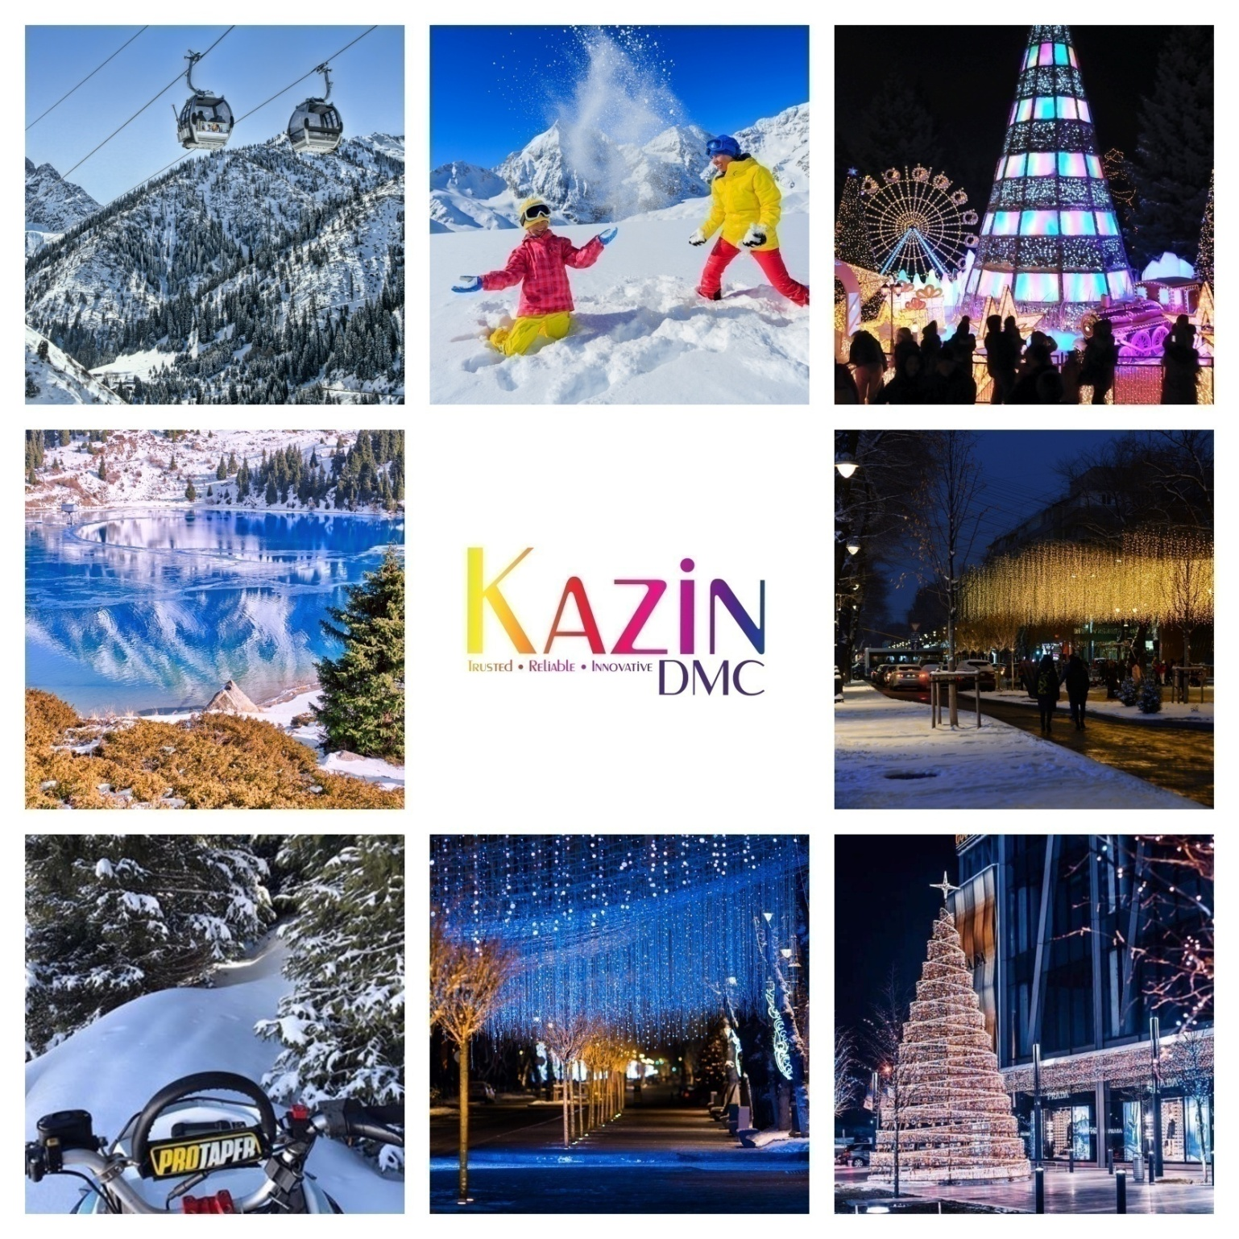

6 NIGHTS (TURKISTAN & ALMATY) + Overnight Train
NVC-FIT-B2B-2024

Validity: 1st March 2024 – 30thDec 2024

DAY 1 | WELCOME TO ALMATY, KAZAKHSTAN!
1600 Hrs | Welcome to Almaty – City of a thousand colours! After clearing custom & immigration procedures followed by baggage collection, you will be met by your English-speaking guide in the arrival’s hall.
1700 Hrs | You will be escorted to your vehicle. Chocolates & refreshing napkins will be served on board your vehicle. Enjoy complimentary Wi-Fi on board your vehicle. Please ask your guide for login details.
1800 Hrs | Welcome to your hotel & check-in to your room.
2000 Hrs | Dinner as per your choice of cuisine or restaurant.
2200 Hrs | Hotel drop-off and good night sleep.

Day 2 | SHYMBULAK SKI RESORT | Walking tour
 | Breakfast at the hotel.
1000 Hrs | Embark on an Unforgettable Journey to Shymbulak Ski Resort (Gondola L3)  Nestled in the heart of the majestic Tien Shan mountains, Shymbulak Ski Resort invites you to experience the pinnacle of winter sports and scenic beauty in Almaty, Kazakhstan. As you ascend to the resort via the gondola lift, prepare to be captivated by the panoramic vistas of snow-capped peaks and alpine meadows, a prelude to the adventure that awaits.
1400 Hrs | Enjoy lunch in Shymbulak or at restaurant of your choice (Direct payment)
1600 Hrs | Proceed to your hotel for some relaxation.
1800 Hrs | Panfilov & Arbat walking tour – The Essence of Almaty  As the day winds down, and the streets light up, the energy of Panfilov Boulevard and Arbat Street remains undiminished. Musicians play into the night, and the conversations continue in cozy cafes. This walking tour isn't just a journey through Almaty's streets; it's an immersion into the city's soul, a blend of history, culture, and lively urban life.
2000 Hrs | Dinner as per your choice of cuisine or restaurant. (Direct payment)
2200 Hrs | Hotel drop-off and good night sleep.

Day 3 | PANFIOV PARK & ZENKOV CATHEDRAL|KOKTOBE
 | Breakfast at your hotel.
1000 Hrs | Almaty city tour  Explore the city of Almaty by quickly getting acquainted with discovering major areas of interest – During this introductory tour, you will visit the First President Park, Republic square, State Opera and Ballet Theatre, museums at the Academy of Sciences, Abay Square, Kazakhstan Hotel, Palace of the Republic.
1200 Hrs | Panfilov Park & Zenkov Cathedral  The Park is named and dedicated to the Panfilov Heroes who were 28 soldiers of an Almaty Infantry. Their memories are etched at the fearsome war memorial east of the Zenkov Cathedral which depict soldiers from all 15 soviet republics on the map of USSR. The Park is lush green area and it’s a good place to sit, rest, relax and see the bustling sights of the city.  ‘Zenkov Cathedral’, is one of the most beautiful, magnificent, and architectural monuments of the city of Almaty with the height of 56 meters and is in the green Panfilov Park of Almaty. A. Zenkov had supervised the construction of this cathedral in the early 19th century and legend goes that it was built without a single nail. But unfortunately, it’s not true. Although the design is remarkably unique but it’s because of the advanced technological expertise of that time.
1400 Hrs | Enjoy lunch at your favourite restaurant.
1600 Hrs | Proceed to your hotel for some relaxation.
1800 Hrs | Visit to Koke Tobe Hill  Kok Tobe is the highest point in the city of Almaty standing on a 1100 m hill at the south-east edge of the city. It is worth a visit to Kok Tobe because of its panoramic view of the city from all directions. To reach the Kokone hill, one should take a cable car ride which starts near Hotel Novotel and goes over some of the oldest parts of Almaty and the magnificent fruit growing gardens. Once you reach the Kok Tobe hill, you would see the famous 372 m high TV Tower which is visible from far and offers great views of the mountains and the city plus many attractions at the top including many restaurants serving cuisines from across the globe.
2000 Hrs | Dinner as per your choice of cuisine or restaurant.
2200 Hrs | Hotel drop-off and good night sleep.

Day 4 | GREEN BAZAAR + RAKHAT CHOCOLATE SHOP
 | Breakfast at the hotel.
1000 Hrs | Green Bazaar + Rakhat Chocolate Shop  If you are among these, who don’t like to go to a mall and prefer the outdoor market among fresh air and belong to the old-school shopping type, then without wasting any time, head straight towards the Zelyony Bazaar located close to the Panfilov Park in Almaty. Also, known as the Green Market, this market is your typical local market where you can purchase everything starting from meat to spices to fruits to even clothes and furniture. The key to shopping here is that you should have a flair for bargaining, and you can get everything at a very reasonable rate.  You will be delighted to see the colourful atmosphere and the variety of goods available.  Right next door is the famous Rakhat Chocolate shop. Rakhat which means pleasure in Kazakh is the oldest manufactures of chocolates dating back to almost 70 years. Around 3500 workers work in basically 2 factories, one located in Almaty and one in Shymkent city. They also make chocolates for people suffering from diabetes and their low-calorie products like candies, cookies and waffles are a range among the people and tourists.
1400 Hrs | Lunch at an Indian restaurant
1500 Hrs | Shopping  Almaty is a paradise for all your shopping, so you can head to some of the swankiest malls the city has to offer. We recommend Dostyk Plaza, Esentai Mall & Mega Mall for high-end quality shopping.
2000 Hrs | Dinner as per your choice of cuisine or restaurant.
2200 Hrs | Hotel drop-off and good night sleep.

Day 5 | OVERNIGHT TRAIN TO SHYMKENT
 | Breakfast at the hotel.
1200 Hrs | Check-out formalities.  Day at disposal for personal activities.
2030 Hrs | Transfer to the railway station to board your modern train (Talgo) to Shymkent City. Talgo trains are renowned for their comfort & speed.  2204 Hrs: Train departs Almaty city.

Day 6 | ARRIVE SHYMKENT | Visit Akmeshit Caves | Ruins of Otrar
0857 Hrs | Welcome to Shymkent
0915 Hrs | Meet & Greet with your experienced tour guide and proceed towards  “Akmeshit Caves” – is a stunning natural limestone cave known for its vast underground chamber, illuminated by a natural skylight that creates a unique microclimate. Its beauty is enhanced by an underground lake believed to have healing properties. Surrounded by dramatic landscape, the cave is a blend of natural mythology, making it a unique and captivating tourist attraction.  Travel Distance: 75 Kms  Travel time: 1 hour 20 minutes.
1200 Hrs | Proceed towards the ancient town of Otrar.  Ruins of Otrar, on the way to Turkestan are an enchanting testament to the ancient grandeur, whispering stories of a once-thriving Silk Road city. Amidst the sun-baked landscapes, these remnants beckon with tales of property, conquest, and scholarly wisdom, offering a mesmerizing glimpse into Central Asia’s rich historical tapestry.  Travel Distance: 155 Kms  Travel time: 2 hour 20 minutes.
1600 Hrs | Procced toward your hotel in “Turkestan”
1700 Hrs | Welcome to your hotel situated in the multi-million-dollar entertainment complex “Karavnsaray” Check-in formalities and time to relax.  Karavansaray is not just a place to relax, it is much more than it seems at first sight. It has a unique soul that offers everyone endless enjoyment of amazing experiences, discoveries, and time travel. From the moment you plunge into the charming atmosphere of Karavansaray, you will get into a fascinating fairy tale praising the great history, culture, and eternal romance of Kazakhstan! Once, having experienced this feeling, love for the Kazakh world will awaken in you forever. Karavansaray- is a fantastic vacation from everyday routine and urban life for you and your loved ones.
2000 Hrs | Experience the 8D Flying theatre:  The Altyn Samyrk 8D Flying Theatre in the Karavansaray entertainment complex in Turkistan is a remarkable attraction that elevates the cinematic experience to new heights. As a flying theatre, it combines 8D technology with a motion-based platform, allowing guests to feel as though they are soaring through the skies. The immersive experience is enhanced with synchronized movements, wind, scents, and other sensory effects, all tailored to the visual journey depicted on screen. Named "Altyn Samyrk," which might reflect a theme or cultural heritage significant to the region, this theatre invites visitors on an unparalleled adventure that blends thrilling sensations with the rich historical and cultural tapestry of Turkistan.
2100 Hrs | An Enchanting Evening of Love and Legend: The Boat Show of Kyz Zhibek and Tolegen As twilight embraces the ancient city of Turkistan, the historic Karawansaray becomes the stage for a captivating evening boat show, a timeless tale of love and fate set against the backdrop of the Silk Road’s splendour. This performance is not just an event; it is the reenactment of the legendary Kazakh epic of "Kyz Zhibek and Tolegen," a story that has stirred the hearts of many through centuries.

Day 7 | DEPARTURE
 | Breakfast at your hotel.
1200 Hrs | Check-out formalities.
 | Transfer to airport for flight to onward destination.

PRICE GRID (Non-Visa Countries) Updated 1st March 2024

7N - Almaty + Silk Route (Turkistan) | Kazzhol Park +  Family Hotel (Karavansaray) |  | Grand Mildom + Family Hotel (Karavansaray) | Novotel Living  + Family Hotel (Karavansaray) | Rahat Palace +  Family Hotel (Karavansaray) | Dostyk + Family Hotel (Karavansaray) | Double Tree By Hilton+ Family Hotel (Karavansaray)
 | 4 **** | 4 **** |  | 4**** | 5***** | 5***** | 5*****
2 Pax | U$ 920 | U$ 922 |  | U$ 1068 | U$31 | U$950 | U$1057
4 Pax | U$ 648 | U$ 650 |  | U$ 798 | U$661 | U$679 | U$786
6 Pax | U$ 574 | U$ 576 |  | U$ 722 | U$586 | U$604 | U$711
8 Pax | U$ 526 | U$ 528 |  | U$ 674 | U$537 | U$556 | U$633
10 Pax | U$ 514 | U$ 516 |  | U$ 662 | U$527 | U$545 | U$652
12 Pax | U$ 492 | U$ 494 |  | U$ 640 | U$504 | U$522 | U$629
14 Pax | U$ 476 | U$ 478 |  | U$ 624 | U$488 | U$506 | U$613
16 Pax | U$ 462 | U$ 464 |  | U$ 612 | U$475 | U$493 | U$600
Single Sup | U$ 236 | U$ 218 |  | U$ 362 | U$185 | U$203 | U$290
CNB (3-11) | U$ 218 | U$ 268 |  | U$ 168 | U$188 | U$188 | U$188
CWB (3-11) | N/A | N/A |  | N/A | N/A | N/A | N/A

INCLUSIONS
- Airport meet & greet.  - Chocolates & refreshing napkins served on board your vehicle.  - Complimentary Wi-Fi on board all our vehicles.  - 4 nights stay in Almaty as per choice of hotels mentioned above.  - 1 night stay in Turkistan  - 1 night Train (Talgo) – Overnight Journey  - Daily breakfast.  - Dedicated English speaking guide throughout the trip.  - Souvenir upon departure courtesy Kazin Dmc. | - Dedicated private vehicle with driver throughout the trip.  - Vehicle & guide at disposal daily for 12 hours  (1000 hrs – 2200 hrs)  - Sightseeing as outlined in the itinerary above.  - Gondola tickets to Shymbulak – Level 3  - Gondola tickets to Kok Tobe.  - 8 D theatre ticket – Once during the stay.  - Entry to Otrar Ruins site.  - 2 bottles of water daily per person.  - Hotel taxes.

EXCLUSIONS | NOTES
- 5% Bed tax payable to the hotel at the time of check-in.  - Flights  - Expenses of personal nature  - Meals (unless or otherwise specified)  - GST & TCS (For India payments only)  - For those who require visa to enter KZ, U$ 85 per person will apply. | - Prices are calculated as per $1=440Tg  - Rates are net & non-commissionable.  - Rates are per person on sharing a room basis.  - Above is a sample price and is subject to availability & currency fluctuation.  - Package is based on flight KC908/907 Ex. Delhi.  - Package price are not valid on black-out/exhibition dates.

SPICE UP YOUR TRIP BY CHOOSING FROM OUR LIST OF ACTIVITIES

S.NO | Activity Name | Price in U$ (Per Person)
1 | Private outdoor picnic set-up with lunch near River/Lakeside | On Request
2 | Private Pool Party in a Villa | On Request
3 | Party in a stretch Limo with music (2 hours) | On Request
4 | Party in a stretch Limo with Hostesses & champagne (2 hours) | On Request
5 | Paragliding | On Request
6 | Go-Karting + Buggy adventure | On Request
7 | Double barrel shotgun shooting experience | On Request
8 | Night club hopping | On Request
9 | 3rd Longest Zipline in the world | On Request
10 | Ski Learning experience (Dec-Apr) | On Request
11 | Snowmobile experience (Dec-Mar) | On Request
12 | Ride a Huskie experience (Dec-Mar) | On Request
13 | Private Pool Villa party | On request
14 | Hot Air Ballooning | On Request
15 | River Rafting with BBQ lunch | On Request
16 | Yacht Party | On Request
17 | Gyro Plane experience | On Request
18 | Cessna – Learn to fly a plane | On request

