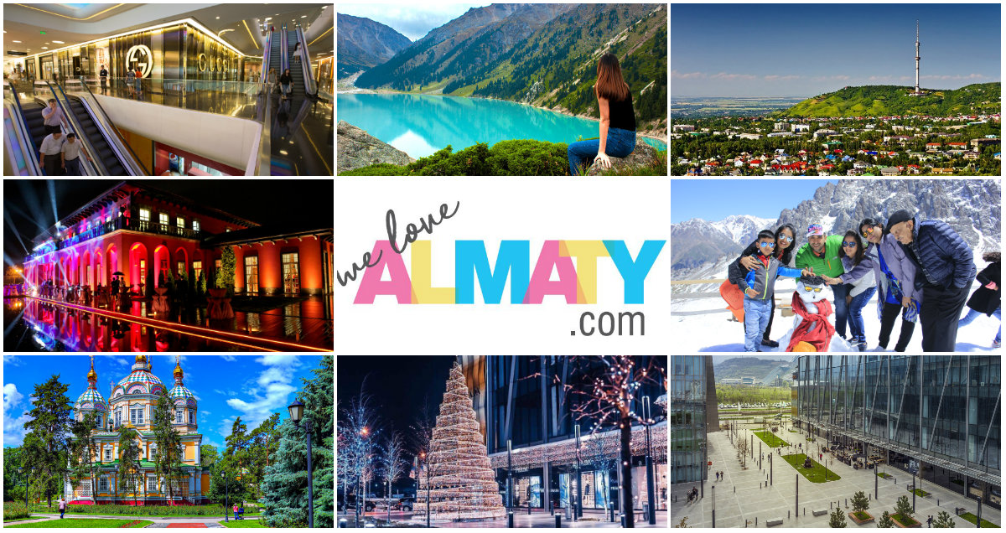

6 Nights
Oi Qaragai Mountain Resort & Almaty city!

NVC-FIT-B2B-2024

Validity: 1stJan 2024 – 30th DEC 2024

DAY 1 | WELCOME TO ALMATY – OI QARAGAI MOUNTAIN RESORT
1500 Hrs | Welcome to Almaty – City of a thousand colours! After clearing custom & immigration procedures followed by baggage collection, you will be met by our English-speaking office staff in the arrival’s hall.
1600 Hrs | Meet & Greet with your tour guide & transfer to the Mountain Resort Oi- Qaragai.  The resort lies in a picturesque mountain gorge and is only a 40-minute drive from Almaty. Upon arriving at Oi Qaragai Mountain resort, one would feel as though you are somewhere in Europe. Surrounded by the virgin nature of the Tien Shan foothills, offering sincere service, Eurasian culture, providing all Guests with the opportunity to get together with the close people, partners, colleagues in active leisure with comfortable living conditions and healthy meals.
1730 Hrs | Arrive at the resort & check-in to your rooms.  Remainder of the day at your leisure to explore the property & it’s surroundings.
 | Enjoy dinner at one of 5 restaurants available on the resort territory. (Direct payment)
DAY 2 | OI QARAGAI MOUNTAIN RESORT
 | Breakfast at the resort.
Day at leisure at the resort

Enjoy various activities provided by the resort –

Paint Ball
Hiking Tours
Mountain Cart
Archery
Rope Park
Climbing Wall Park
Zip Line
Horse Riding
Spa
 | Enjoy Lunch at one of 5 restaurants available on the resort territory. (Direct payment)
 | Enjoy dinner at one of 5 restaurants available on the resort territory. (Direct payment)

DAY 3 | WELCOME TO ALMATY
1545 Hrs | Breakfast at the hotel.
1200 Hrs | Check-out formalities. You will be met by your English-speaking tour guide and driver.  Transfer to your city hotel & Check-in.
1900 Hrs | Panfilov Promenade&Arbat walking tour  Evening walk around Panfilov promenade. The promenade which overlooks the Kazakh Opera & Ballet theatre is lined with small shops, eateries, and cafes & beautiful lights. You will enjoy hearing many local musicians singing songs & playing local musical instruments. The tour will end on Arbat street.
2000 Hrs  2200 Hrs | Dinner at restaurant of your choice. (Direct payment)  Hotel drop-off.

Day 4 | ISSYK LAKE |ALMA-ARASAN| FALCON SHOW
 | Breakfast at the hotel.
1000 Hrs | Visit to Issyk Lake!!  The Issyk Lake tour is especially designed for all mountain lovers who can first hike to the beautiful cliffs called ‘The Kremlin walls’ and later camp at the lake side taking in the fresh air and scenic beauty. The tour would start by taking you to the spectacular gorges of Trans-Ili- Alatau along the Kuldja tract famous for trade caravans. In between, you would get a dose on history, as the tour would take you to see the burial mounds of the Saka Period, the Ostrich Farm and the Issyk Barrow. The route would finally take you to Issyk Lake, where you can enjoy the breath-taking beauty of the turquoise water surface and a view of the surrounding area. One can click photographs to seize the moment or can just laze around and read a book or soak in the silence of the natural beauty.
1400 Hrs | Lunch at restaurant of your choice. (Direct payment)
1500 Hrs | Almarasan George  The Almarasan George is inaccessible from the bottem; the bridge on the trail along the river has been washed away. And the trail through the former Almarasan sanatorium is blocked by a private territory guarded by men with machineguns. The private territory stretches for serval tens of hectares.
1700 Hrs | Falcon Show  You visit falcon farm, where it is possible to see an unforgettable show with birds of prey,  and later it will be possible to look at their life, to take a set of pictures and with great.  Mood to return to the city.
2000 Hrs | Dinner at restaurant of your choice. (Direct payment)
2200 Hrs | Hotel drop-off.

Day 5 | PANFIOV PARK & ZENKOV CATHEDRAL|KOKTOBE
0700 – 1000 Hrs | Breakfast at the hotel.
1030 Hrs | Panfiov Park &Zenkov Cathedral  Its Almaty’s most popular strolling and picnic places for people of all ages. The Park is named and dedicated to the Panfilov Heroes who were 28 soldiers of an Almaty Infantry. Their memories are etched at the fearsome war memorial east of the Zenkov Cathedral which depict soldiers from all 15 soviet republics on the map of USSR. The Park is lush green area and it’s a good place to sit, rest, relax and see the bustling sights of the city.  ‘ZenkovCathedral’, is one of the most beautiful, magnificent and architectural monuments of the city of Almaty with the height of 56 meters and is located in the green Panfilov Park of Almaty. A. Zenkov had supervised the construction of this cathedral in the early 19th century and legend goes that it was built without a single nail. But unfortunately, it’s not true. Although the design is remarkably unique but it’s because of the advanced technological expertise of that time. They used the construction concept of Semi ruche which meant using of reinforced concrete, timber preservation and ventilation.
1400 Hrs | Lunch at restaurant of your choice. (Direct payment)
1730 Hrs | Visit to KokeTobe Hill  KokTobe is the highest point in the city of Almaty standing on a 1100 m hill at the south-east edge of the city. It is worth a visit to KokTobe because of its panoramic view of the city from all directions. To reach the KokTobe hill, one should take a cable car ride which starts near Hotel Kazakhstan and goes over some of the oldest parts of Almaty and the magnificent fruit growing gardens. Once you reach the KokTobe hill, you would see the famous 372 m high TV Tower which is visible from far and offers great views of the mountains and the city plus many attractions at the top including many restaurants serving cuisines from across the globe.
2000 Hrs | Dinner at restaurant of your choice. (Direct payment)
2200 Hrs | Hotel drop-off.

Day 6 | SHYMBULAK| GREEN BAZAAR + RAKHAT CHOCOLATE SHOP
0700 – 1000 Hrs | Breakfast at the hotel.
1000 Hrs | Visit to Shymbulak Ski resort  Proceed on an excursion to the beautiful mountain resort of Shymbulak via Gondola to level3and services of our English-speaking guide.  “Shymbulak Ski Resort” is in the beautiful ZailiyskiyAlatau mountain at 2260 above sea level. It is 25 Km from theCityCentreofAlmaty city and has an average temperature of +25C in the summer &-7C in the winter months. The average snowfall is around 1.5M. It is usually very sunny as the average number of sunny days a year can reach 90%. Ski seasonnormally beginning in December and can run in April.
1400 Hrs | Lunch at restaurant of your choice. (Direct payment)
1500 Hrs | Green Bazaar + Rakhat Chocolate Shop  If you are among these, who don’t like to go to a mall and prefer the outdoor market among fresh air and belong to the old-school shopping type, then without wasting any time, head straight towards the Zelyony Bazaar located close to the Paniflov Park in Almaty. Also, known as the Green Market, this market is your typical local market where you can purchase everything starting from meat to spices to fruits to even clothes and furniture. The key to shopping here is that you should have a flair for bargaining, and you can get everything at a very reasonable rate.  You will be delighted to see the colourful atmosphere and the variety of goods available.  Right next door is the famous Rakhat Chocolate shop. Rakhat which means pleasure in Kazakh is the oldest manufactures of chocolates dating back to almost 70 years. Around 3500 workers work in basically 2 factories, one located in Almaty and one in Shymkent city. They also make chocolates for people suffering from diabetes and their low-calorie products like candies, cookies and waffles are a range among the people and tourists.
2000 Hrs | Dinner at restaurant of your choice. (Direct payment)
2200 Hrs | Hotel drop-off.

Day 7 | RETURN HOME
0430 Hrs | Packed breakfast &check-out from the hotel.  It’s time to say good-bye to this beautiful city. Our driver will pick you up from the hotel and transfer you to the airport for your flight home or to an onward destination.

PRICE GRID (Non-Visa Countries-2024) Updated 1stFeb 2024

6N- Qaragai MountainResort & Almaty | Holiday Inn Express | Kazakhstan Hotel | Holiday  Inn | Kazzhol Almaty | kazzhol Park | Grand Mildom | Novotel Living | Rahat Palace | Dostyk | DoubleTree by Hilton
 | 3 *** | 4 **** | 4 **** | 4 **** | 4 **** | 4**** | 4 **** | 5 ***** | 5***** | 5*****
2 Pax | U$ 775 | U$ 707 |  | U$ 768 | U$ 814 | U$ 817 | U$ 963 | U$ 827 | U$ 877 | U$ 953
4 Pax | U$ 686 | U$ 618 |  | U$ 680 | U$ 726 | U$ 728 | U$ 874 | U$738 | U$ 788 | U$ 864
6 Pax | U$ 594 | U$ 526 |  | U$ 587 | U$ 633 | U$ 636 | U$ 782 | U$ 646 | U$ 692 | U$ 772
8 Pax | U$ 551 | U$ 483 |  | U$ 545 | U$ 591 | U$ 593 | U$ 739 | U$ 603 | U$ 650 | U$ 729
10 Pax | U$ 547 | U$ 478 |  | U$ 540 | U$ 586 | U$ 588 | U$ 734 | U$ 598 | U$ 649 | U$ 724
12 Pax | U$ 526 | U$ 458 |  | U$ 519 | U$ 565 | U$ 567 | U$ 714 | U$ 578 | U$ 628 | U$ 703
14 Pax | U$ 511 | U$ 443 |  | U$ 505 | U$ 551 | U$ 553 | U$ 699 | U$ 563 | U$ 613 | U$ 689
16 Pax | U$ 500 | U$ 432 |  | U$ 494 | U$ 540 | U$ 542 | U$ 688 | U$ 552 | U$ 602 | U$ 678
Single Sup | U$ 299 | U$ 248 |  | U$ 320 | U$ 366 | U$ 347 | U$ 494 | U$ 316 | U$ 313 | U$ 420
CNB (3-11) | N/A | U$ 145 |  | U$ 145 | U$ 145 | U$ 145 | N/A | U$ 156 | N/A | N/A
CWB (3-11) | N/A | N/A |  | N/A | N/A | N/A | N/A | U$ 245 | N/A | N/A

UPGRADE TO FULL BOARD  On Request  (Valid for group size of 8 people and above) | UPGRADE TO INTERNATIONAL MEALS  Pay U$ 20 per person/per meal and enjoy delicious international food. (Valid for lunch only from Mon-Fri) – Set Menu

INCLUSIONS
- Airport meets& greet.  - Chocolates & refreshing napkins served on board your vehicle.  - Complimentary Wi-Fi on board all our vehicles.  - 2 nights stay at Oi-Qaragai Mountain resort in a Treehouse. ( Without balcony)  - 4 nights stay as per choice of hotels mentioned above.  - Daily breakfast.  - Dedicated English speaking guide throughout the trip.  - Souvenir upon departure courtesy Kazin Dmc. | - Dedicated private vehicle with driver throughout the trip.  - Vehicle & guide at disposal daily for 12 hours  (1000 hrs – 2200 hrs) – City portion only  - Sightseeing as outlined in the itinerary above.  - Gondola tickets to Shymbulak – Level 3  - Gondola tickets to KokTobe.  - Falcon Show entrance  - 2 bottles of water daily per person.  - Hotel taxes.

EXCLUSIONS | NOTES
- 5% Bed tax payable to the hotel at the time of check-in.  - Flights  - Expenses of personal nature  - Meals (unless or otherwise specified)  - GST & TCS (For India only)  - For those who require visa to enter KZ, U$ 85 per person will apply – E-visa eligible countries. | - Prices are calculated as per $1=440Tg  - Rates are net & non-commissionable.  - Rates are per person on sharing a room basis.  - Above is a sample price and is subject to availability & currency fluctuation.  - Package is based on flight KC908/907 Ex. Delhi.  - Package price are not valid on black-out/exhibition dates.  - 2 Pax cost is based on English speaking driver-cum guide

SPICE UP YOUR TRIP BY CHOOSING FROM OUR LIST OF ACTIVITIES

S.NO | Activity Name | Price in U$ (Per Person)
1 | Private outdoor picnic set-up with lunch near River/Lakeside | On Request
2 | Private Pool Party in a Villa | On Request
3 | Party in a stretch Limo with music (2 hours) | On Request
4 | Party in a stretch Limo with Hostesses & champagne (2 hours) | On Request
5 | Paragliding | On Request
6 | Go-Karting + Buggy adventure | On Request
7 | Double barrel shotgun shooting experience | On Request
8 | Night club hopping | On Request
9 | 3rd Longest Zipline in the world | On Request
10 | Ski Learning experience (Dec-Apr) | On Request
11 | Snowmobile experience (Dec-Mar) | On Request
12 | Ride a Huskie experience (Dec-Mar) | On Request
13 | Private Pool Villa party | On request
14 | Hot Air Ballooning | On Request
15 | River Rafting with BBQ lunch | On Request
16 | Yacht Party | On Request
17 | Gyro Plane experience | On Request
18 | Cessna – Learn to fly a plane | On request

