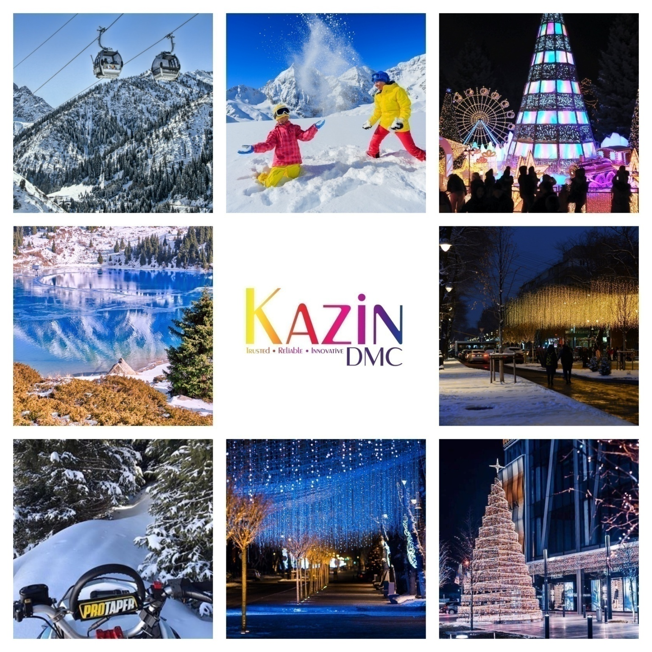

4 NIGHTS (ALMATY WITH A VIEW)
NVC-FIT-B2B-2024

Validity: 1stJan 2024 – 30thDec 2024

DAY 1 | WELCOME TO ALMATY, KAZAKHSTAN!
1600 Hrs | Welcome to Almaty – City of a thousand colours! After clearing custom & immigration procedures followed by baggage collection, you will be met by your English-speaking guide in the arrival’s hall.
1700 Hrs | You will be escorted to your vehicle. Chocolates & refreshing napkins will be served on board your vehicle. Enjoy complimentary Wi-Fi on board your vehicle. Please ask your guide for login details.
1800 Hrs | Welcome to your hotel & check-in to your room.
2000 Hrs | Dinner as per your choice of cuisine or restaurant.
2200 Hrs | Hotel drop-off and good night sleep.

Day 2 | SHYMBULAK SKI RESORT
 | Breakfast at the hotel.
1000 Hrs | Visit the Shymbulak Ski resort – Level 3 via Gondola  In just 1 hour, you can get from Almaty city center to its highest point (3200 meters) and drink coffee in the highest bar in the CIS using 3 tier world-class Gondola.  On Shymbulak, you can have a great time even if you can’t ski or snowboard. An all-day entertainment for the whole family is provided by cafes and restaurants with excellent cuisine, an observation deck with powerful binoculars that rotate 360 degrees and a playground. For those who want to enjoy the mountain silence and admire the snowy slopes, the resort offers high-class hotels and various kinds of adventure activities such as Zip  Lining, Paragliding, Horse riding etc.
1400 Hrs | Enjoy lunch in Shymbulak or a choice of your restaurant in the city.
1600 Hrs | Proceed to your hotel for some relaxation.
1800 Hrs | Panfilov &Arbat walking tour  Evening walk around Panfilov promenade. The promenade which overlooks the Kazakh Opera & Ballet theatre is lined with small shops, eateries, and cafes & beautiful lights. You will enjoy hearing many local musicians singing songs & playing local musical instruments. The tour will end on Arbat street with lots of shopping outlets and street entertainment.
2000 Hrs | Dinner as per your choice of cuisine or restaurant.
2200 Hrs | Hotel drop-off and good night sleep.

Day 3 | PANFIOV PARK & ZENKOV CATHEDRAL|KOKTOBE
 | Breakfast at your hotel.
1000 Hrs | Almaty city tour  Explore the city of Almaty by quickly getting acquainted with discovering major areas of interest – During this introductory tour, you will visit the First President Park, Republic square, State Opera and Ballet Theatre, museums at the Academy of Sciences, Abay Square, Kazakhstan Hotel, Palace of the Republic.
1200 Hrs | Panfilov Park &Zenkov Cathedral  The Park is named and dedicated to the Panfilov Heroes who were 28 soldiers of an Almaty Infantry. Their memories are etched at the fearsome war memorial east of the Zenkov Cathedral which depict soldiers from all 15 soviet republics on the map of USSR. The Park is lush green area and it’s a good place to sit, rest, relax and see the bustling sights of the city.  ‘Zenkov Cathedral’, is one of the most beautiful, magnificent, and architectural monuments of the city of Almaty with the height of 56 meters and is in the green Panfilov Park of Almaty. A. Zenkov had supervised the construction of this cathedral in the early 19th century and legend goes that it was built without a single nail. But unfortunately, it’s not true. Although the design is remarkably unique but it’s because of the advanced technological expertise of that time.
1400 Hrs | Enjoy lunch at your favourite restaurant.
1600 Hrs | Proceed to your hotel for some relaxation.
1800 Hrs | Visit to KokeTobe Hill  KokTobe is the highest point in the city of Almaty standing on a 1100 m hill at the south-east edge of the city. It is worth a visit to KokTobe because of its panoramic view of the city from all directions. To reach the KokTobe hill, one should take a cable car ride which starts near Hotel Novotel and goes over some of the oldest parts of Almaty and the magnificent fruit growing gardens. Once you reach the KokTobe hill, you would see the famous 372 m high TV Tower which is visible from far and offers great views of the mountains and the city plus many attractions at the top including many restaurants serving cuisines from across the globe.
2000 Hrs | Dinner as per your choice of cuisine or restaurant.
2200 Hrs | Hotel drop-off and good night sleep.

Day 4 | GREEN BAZAAR + RAKHAT CHOCOLATE SHOP
 | Breakfast at the hotel.
1000 Hrs | Green Bazaar + Rakhat Chocolate Shop  If you are among these, who don’t like to go to a mall and prefer the outdoor market among fresh air and belong to the old-school shopping type, then without wasting any time, head straight towards the Zelyony Bazaar located close to the Panfilov Park in Almaty. Also, known as the Green Market, this market is your typical local market where you can purchase everything starting from meat to spices to fruits to even clothes and furniture. The key to shopping here is that you should have a flair for bargaining, and you can get everything at a very reasonable rate.  You will be delighted to see the colourful atmosphere and the variety of goods available.  Right next door is the famous Rakhat Chocolate shop. Rakhat which means pleasure in Kazakh is the oldest manufactures of chocolates dating back to almost 70 years. Around 3500 workers work in basically 2 factories, one located in Almaty and one in Shymkent city. They also make chocolates for people suffering from diabetes and their low-calorie products like candies, cookies and waffles are a range among the people and tourists.
1400 Hrs | Lunch at an Indian restaurant
1500 Hrs | Shopping  Almaty is a paradise for all your shopping, so you can head to some of the swankiest malls the city has to offer. We recommend Dostyk Plaza, Esentai Mall & Mega Mall for high-end quality shopping.
2000 Hrs | Dinner as per your choice of cuisine or restaurant.
2200 Hrs | Hotel drop-off and good night sleep.

Day 5 | RETURN HOME
0400 – 0430 Hrs  0430 Hrs | Packed breakfast &check-out from the hotel.  It’s time to say good-bye to this beautiful city. Our driver will pick you up from the hotel and transfer you to the airport for your flight home or to an onward destination

PRICE GRID (Non-Visa Countries-2024) Updated1stJAN 2024

4N- Almaty with a view | Holiday Inn Express | Kazakhstan Hotel | Holiday  Inn | Kazzhol Almaty | Kazzhol Park | Novotel Living | Grand Mildom | Rahat Palace | Dostyk | Double Tree By Hilton
 | 3 *** | 4 **** | 4 **** | 4 **** | 4 **** | 4 **** | 4**** | 5***** | 5***** | 5*****
2 Pax | U$ 594 | U$ 390 |  | U$ 455 | U$ 502 |  | U$ 510 | U$ 515 | U$ 585 | U$ 640
4 Pax | U$ 500 | U$ 345 |  | U$ 405 | U$ 449 |  | U$ 465 | U$ 460 | U$ 530 | U$ 585
6 Pax | U$ 400 | U$ 280 |  | U$ 335 | U$ 384 |  | U$ 398 | U$ 395 | U$ 465 | U$ 520
8 Pax | U$ 360 | U$ 250 |  | U$ 308 | U$ 357 |  | U$ 375 | U$ 370 | U$ 440 | U$ 492
10 Pax | U$ 355 | U$ 255 |  | U$ 315 | U$ 360 |  | U$ 378 | U$ 375 | U$ 445 | U$ 498
12 Pax | U$ 336 | U$ 240 |  | U$ 300 | U$ 349 |  | U$ 365 | U$ 360 | U$ 430 | U$ 485
14 Pax | U$ 320 | U$ 230 |  | U$ 305 | U$ 337 |  | U$ 355 | U$ 349 | U$ 420 | U$ 475
16 Pax | U$ 310 | U$ 225 |  | U$ 286 | U$ 330 |  | U$ 348 | U$ 345 | U$ 410 | U$ 466
Single Sup | U$ 130 | U$ 80 |  | U$ 152 | U$ 198 |  | U$ 178 | U$ 148 | U$ 204 | U$ 250
CNB (3-11) | N/A | U$ 70 |  | U$ 98 | U$ 97 |  | U$ 98 | U$ 109 | N/A | N/A
CWB (3-11) | N/A | N/A |  | N/A | N/A |  | N/A | U$ 155 | N/A | N/A

UPGRADE TO FULL BOARD  Pay U$ 84 per person and enjoy delicious Indian meals, daily.  (Valid for group size of 8 people and above) | UPGRADE TO INTERNATIONAL MEALS  Pay U$ 20 per person/per meal and enjoy delicious international food. (Valid for lunch only from Mon-Fri) – Set Menu

INCLUSIONS
- Airport meet & greet.  - Chocolates & refreshing napkins served on board your vehicle.  - Complimentary Wi-Fi on board all our vehicles.  - 4 nights stay as per choice of hotels mentioned above.  - Daily breakfast.  - Dedicated English speaking guide throughout the trip.  - Souvenir upon departure courtesy Kazin Dmc. | - Dedicated private vehicle with driver throughout the trip.  - Vehicle & guide at disposal daily for 12 hours  (1000 hrs – 2200 hrs)  - Sightseeing as outlined in the itinerary above.  - Gondola tickets to Shymbulak – Level 3  - Gondola tickets to Kok Tobe.  - 2 bottles of water daily per person.  - Hotel taxes.

EXCLUSIONS | NOTES
- 5% Bed tax payable to the hotel at the time of check-in.  - Flights  - Expenses of personal nature  - Meals (unless or otherwise specified)  - GST & TCS (For India only)  - For those who require visa to enter KZ, U$ 85 per person will apply. | - Prices are calculated as per $1=440Tg  - Rates are net & non-commissionable.  - Rates are per person on sharing a room basis.  - Above is a sample price and is subject to availability & currency fluctuation.  - Package is based on flight KC908/907 Ex. Delhi.  - Package price are not valid on black-out/exhibition dates.  - 2 Pax cost is based on English speaking driver-cum guide.

SPICE UP YOUR TRIP BY CHOOSING FROM OUR LIST OF ACTIVITIES

S.NO | Activity Name | Price in U$ (Per Person)
1 | Private outdoor picnic set-up with lunch near River/Lakeside | On Request
2 | Private Pool Party in a Villa | On Request
3 | Party in a stretch Limo with music (2 hours) | On Request
4 | Party in a stretch Limo with Hostesses & champagne (2 hours) | On Request
5 | Paragliding | On Request
6 | Go-Karting + Buggy adventure | On Request
7 | Double barrel shotgun shooting experience | On Request
8 | Night club hopping | On Request
9 | 3rd Longest Zipline in the world | On Request
10 | Ski Learning experience (Dec-Apr) | On Request
11 | Snowmobile experience (Dec-Mar) | On Request
12 | Ride a Huskie experience (Dec-Mar) | On Request
13 | Private Pool Villa party | On request
14 | Hot Air Ballooning | On Request
15 | River Rafting with BBQ lunch | On Request
16 | Yacht Party | On Request
17 | Gyro Plane experience | On Request
18 | Cessna – Learn to fly a plane | On request

