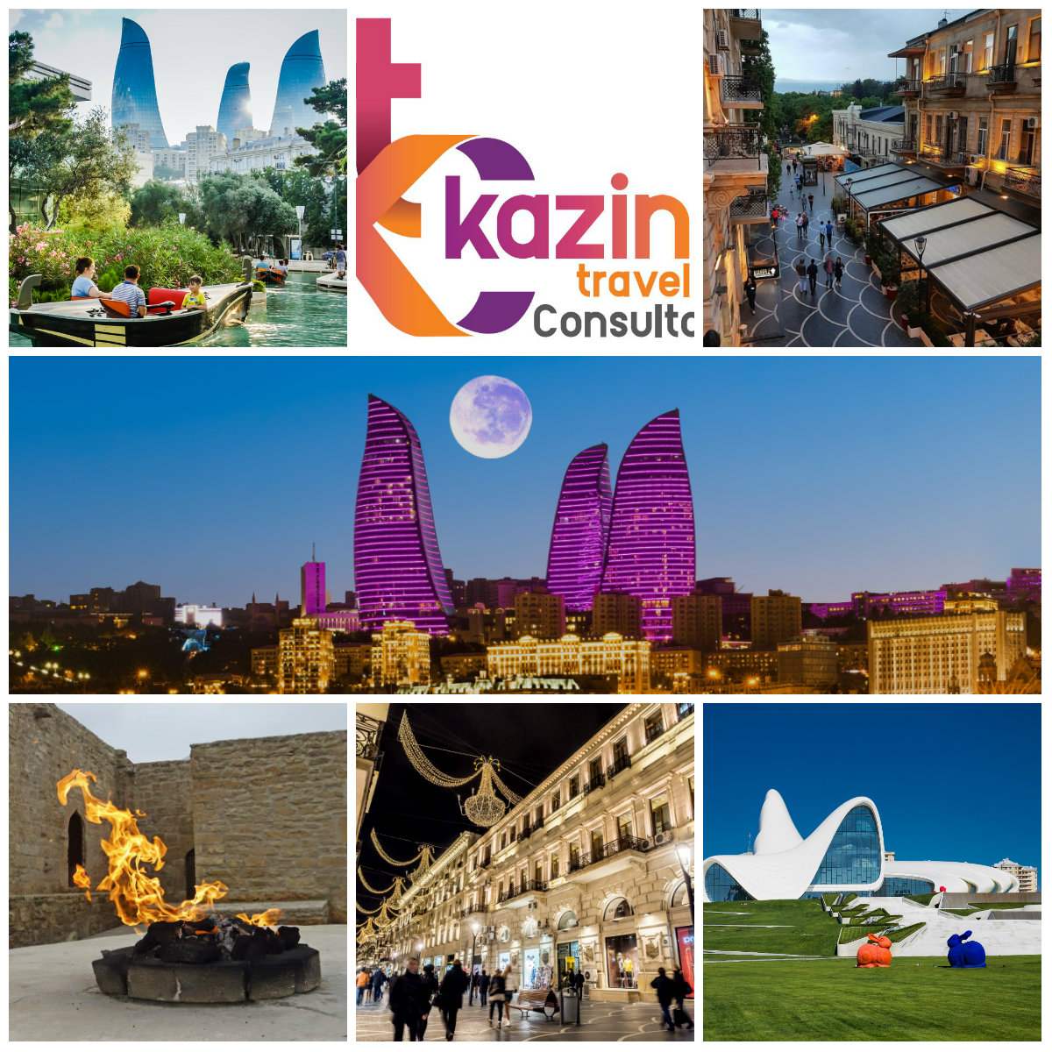

You are about to discover a country of ancient culture and unique nature. Azerbaijan is one of the most ancient countries that is placed on the Silk Way, where the European and Asian way of life and traditions merge for thousands of years. It is the destination to see!

**INDIA MARKET with Indigo**

3 NIGHTS (WE LOVE BAKU)
NVC-FIT-B2B-2024
Validity: 1stJan 2024 – 31st Mar 2024

DAY 1 | WELCOME TO BAKU
2330 Hrs | WELCOME TO BAKU!  Arrive at Heydar Aliyev International Airport. After immigration & collecting your bags, meet our representative at the airport. After a warm welcome, proceed to hotel & Check-in.

DAY 2 | EXPLORE BAKU – CITY OF GOD!
 | Breakfast at your hotel.
1000 Hrs | The Old City Tour.  Baku Old City, also known as Icherisheher, is a historic core that reflects the rich cultural and architectural heritage of Azerbaijan's capital, Baku. Exploring the Old City is like taking a journey back in time, as it is a UNESCO World Heritage site that has preserved its medieval charm amidst the modern developments in the surrounding areas.
1200 Hrs | Walking Tour of Nizami Street  The second destination of the Baku City tour is Nizami Street which is a large pedestrian and shopping street in downtown Baku, Azerbaijan, named after classical poet Nizami Ganjavi. The street’s history could be traced back to Baku’s town-planning project of 1864. The street runs through the city’s downtown from west to east. It begins from Abdulla Shaiq Street, in the mountainous part of the city and ends at a railroad bed on Sabit Orujov Street. The total length of the street is 3,538 m.  Nizami Street is home to various outlets, from banks to fashion stores, and is one of the most expensive streets in the world.
1400 Hrs | Lunch at a restaurant of your choice (Direct Payment)
1600 Hrs | Highland Park + Funicular experience  This comes with the terrific seashore. The funicular here in the Highland Park has been constructed around the 1940s and this beautiful funicular has been here in Azerbaijan since then. The highlight of the Highland Park is the extraordinary stairway. The beautiful stairway seems like a walk every tourist should take at least once to be able to live every beautiful moment of this splendid architecture. The tourists usually spend a lot of time trying to seep in all that the beautiful sightings of the Highland Park have to offer. The scenic beauty is something one cannot miss out on!
1800 Hrs | The cultural Centre of Heydar Aliyev  We will have a visit to the charming example of modern architecture - The Heydar Aliyev Centre - a 57,500 m2 building complex in Baku, Azerbaijan designed by Iraqi-British architect Zaha Hadid and noted for its distinctive architecture and flowing, curved style that eschews sharp angles. The centre is named after Heydar Aliyev, the first secretary of Soviet Azerbaijan from 1969 to 1982, and president of Azerbaijan Republic from October 1993 to October 2003. (Photo stop)
2000 Hrs | Hotel or Restaurant Drop-Off.

DAY 3 | ABSHERON TOUR + SHOPPING
 | Breakfast at the hotel.
1000 Hrs | FIRE WORSHIPPERS’ TEMPLE  The most famous fire temple is the well-preserved temple Ateshgah ("the Fireplace") in Surakhany, the temple was built over a pocket of natural gas that fuelled a vent providing an 'eternal' fire.
1230 Hrs | YANAR DAG “BURNING MOUNTAIN”  Trip to Yanar Dag, also known as ‘Burning Mountain’. True to its name, the mountain has been burning for as long as anyone can remember, and the fire isn’t showing signs of going out any time soon. Situated on the Absheron Peninsula, 25 kilometres northeast of the capital city of Baku, Yanar Dag is a 116-meter hill located on top of a pocket of natural gas that constantly erupts into flames
1400 Hrs | Lunch Time (Direct Payment)
1600 Hrs | WALKING TOUR OF BOULEVARD  Near Boulevard your walking tour will start. You will stroll along Baku Boulevard and taking in views of the Caspian Sea. As you stroll through the illuminated Baku Boulevard, your guide will share a local’s perspective on daily life in Baku, will teach you about the city’s past and present and point out the best spots point out favourite cafés, restaurants, and galleries that many visitors miss.  Discover the magic of Baku at night from your comfortable coach with a leisurely evening walking tour. Stroll along the Boulevard, admire the Venice and experience the vibrant nocturnal energy of Baku.
2000 Hrs | Hotel or Restaurant Drop-Off.

Day 4 | SHOPPING & TRANSFER
 | Breakfast at the hotel.
1200 Hrs | Check-out formalities.
1200 Hrs | Explore the shopping scene of Baku by visiting various local & modern shopping malls.
1400 Hrs | Lunch Time (Direct Payment)
2000 Hrs | Transfer to the airport.

PRICE GRID (2024) Updated 1st JAN 2024

3N - We Love Baku | Parkside | Badamdar | Dinamo | Hyatt | Marriott Boulevard
 | 4**** | 5***** | 5***** Boutique | 5***** | 5*****
2 Pax | U$ 200 | U$ 242 | U$ 275 | U$ 322 | U$ 258
4 Pax | U$ 192 | U$ 234 | U$ 266 | U$ 312 | U$ 248
6 Pax | U$ 182 | U$ 224 | U$ 258 | U$ 304 | U$ 238
8 Pax | U$ 166 | U$ 208 | U$ 240 | U$ 286 | U$ 222
10 Pax | U$ 156 | U$ 198 | U$ 230 | U$ 276 | U$ 212
12 Pax | U$ 152 | U$ 194 | U$ 228 | U$ 274 | U$ 210
14 Pax | U$ 148 | U$ 190 | U$ 222 | U$ 268 | U$ 204
16 Pax | U$ 144 | U$ 186 | U$ 218 | U$ 264 | U$ 200
Single Sup | U$ 86 | U$ 92 | U$ 174 | U$ 160 | U$ 122
CNB (3-11) | U$ 25 | U$ 65 | U$ 18 | U$ 20 | U$ 55
CWB (3-11) | U$ 58 | N/A | U$ 120 | U$ 152 | U$ 98
UPGRADE TO DAILY INDIAN MEALS (SET MENU)
U$ 75 Per Adult

INCLUSIONS
- Airport meet & greet.  - 3 nights stay as per choice of hotels mentioned above.  - Daily breakfast.  - Dedicated English speaking guide throughout the trip.  - Dedicated private vehicle with driver throughout the trip. | - Vehicle & guide at disposal daily for 10 hours  (1000 hrs – 2000 hrs)  - Sightseeing as outlined in the itinerary above.  - Fire Temple & Fire Mountain Tickets Included.  - Funicular tickets included.  - 2 bottles of water daily per person.  - Hotel taxes.

EXCLUSIONS | NOTES
- Flights  - Expenses of personal nature  - Meals (unless or otherwise specified)  - For those who require visa to enter AZ, U$ 30 per person will apply. (E-Visa applicants only) | - Prices are calculated as per $1=1.68AZN  - Rates are net & non-commissionable.  - Rates are per person on sharing a room basis.  - Above is a sample price and is subject to availability & currency fluctuation.  - Package is based on flight 6E-1803/6E-1804  - For 2 guests – We will provide driver cum guide.  - Package prices are not valid on black-out/exhibition dates.  - For Bank payments please add 4% bank charges.

UPGRADE YOUR TRIP FROM OUR OUR LIST OF ACTIVITIES

S.NO | Activity Name | Price in U$ (Per Person)
1 | Gun Shooting Experience (10 bullets) | U$ 15
2 | Visit a real Oil Tanker | U$ 5
3 | Caspian Sea Boat Cruise (Summer only) | U$ 8
4 | Go-Karting experience | On Request
5 | Day Trip to Gabala with Tufan Dag Cable Car + Shamkhi visit | On Request
6 | Day Trip to Shahdag | On Request

** Activities prices mentioned above are for guidance purposes only. Exact price will depend on the number of people participating in the activity**

