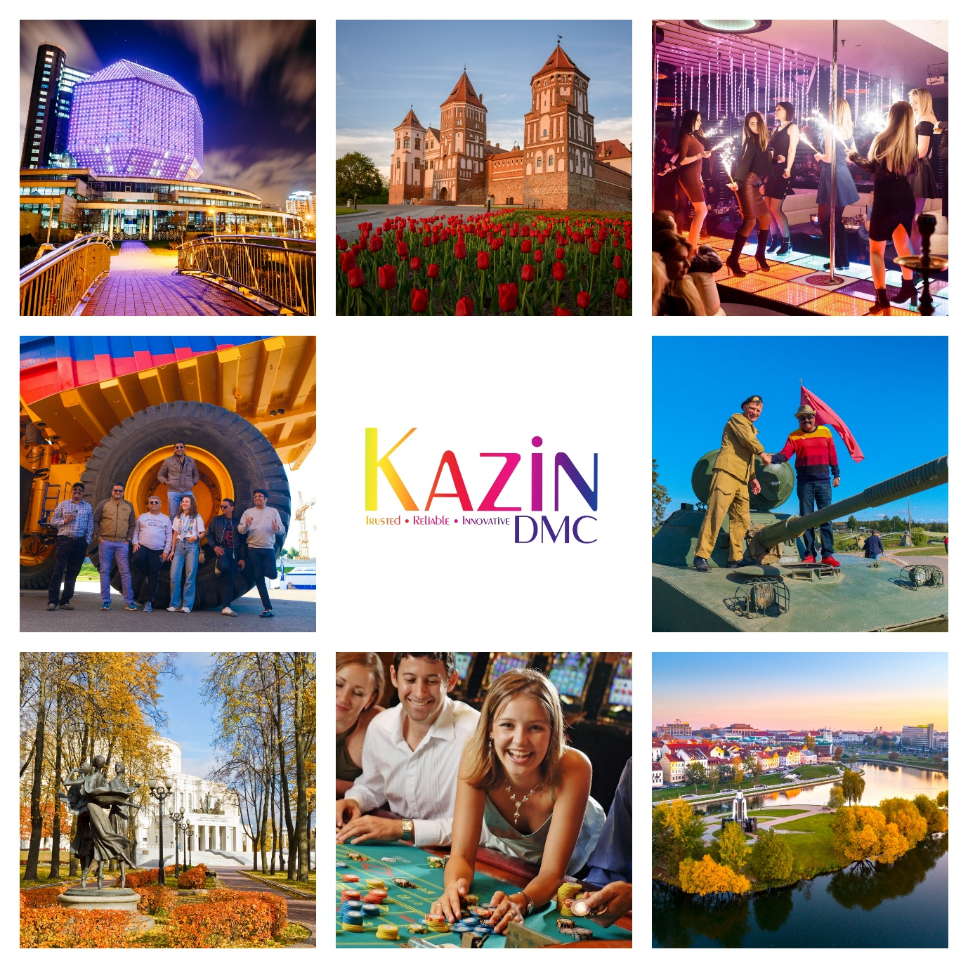

3 Nights – Best of Minsk

Minsk will certainly surprise you. The capital of Belarus is a progressive, modern, clean, calm, and peaceful place. Fashionable cafes, impressive restaurants and crowded nightclubs vie for your attention, while sushi bars and art galleries have taken up residence in a city centre once totally remodelled to the tastes of Stalin, in the Soviet Union.

Day 01 | WELCOME TO MINSK
11:40 Hrs | Welcome to Minsk!! After clearing custom & immigration procedures followed by baggage collection, you will be met by your English-speaking guide in the arrival’s hall.
12:40 Hrs | Our team will escort the group to their vehicle. Proceed to your hotel. Upon arrival at the hotel group will check-in to their respective rooms. Relax with time at leisure.
18:00 Hrs | ORIENTATION TOUR OF MINSK  You will get an unforgettable immersion in the history of the city. Minsk was first mentioned in chronicles of the 11th century, and 950 years later, it’s keeping its secrets and mysteries. Our experienced guides will tell you interesting facts and stories about Minsk and Belarus, will reveal the connection of times, and will move you to the era of the Minsk "Babylon". You will visit the Upper Town, Independence Square, Independence Avenue and much more.
20:00 Hrs | Dinner at a restaurant of your choice. (direct payment)
22:00 Hrs | Hotel drop-off

Day 02 | BELAZ FACTORY | NATIONAL LIBRARY
 | Breakfast at the hotel.
10:00 Hrs | BELAZ FACTORY EXPERIENCE (60 KMS)  We invite you to visit the world-famous brand – the Belarusian automobile plant BELAZ. A place, where up-to date giants are born !  You will travel along the facilities of the factory and personally see the process of assembling BELAZ mining dump trucks.  You will be allowed to see the range of the mining equipment, climb the hugest dump track of the factory and take amazing pictures with its background.
14:00 Hrs | Lunch at a restaurant of your choice. (direct payment)
18:00 Hrs | NATIONAL LIBRARY & OBSERVATION DECK  It feels like the world first learned about the word “rhombicuboctahedron” after the construction of the national library of Belarus. With 18 square and 8 triangular faces, this eccentric geometric shape has been turning heads since the library’s construction. It symbolizes the value of knowledge and the infinity of the perceptible world.  At night the library is illuminated and shows various displays. Due to its unusual shape and bright illumination, the library has almost become one of the key attractions in Minsk.  The open-air observation deck is located over 70 meters above the ground in the upper part of the repository. Visitors can take a panoramic elevator to it to enjoy amazing city views.
20:00 Hrs | Dinner at a restaurant of your choice. (direct payment)
22:00 Hrs | Hotel drop-off

Day 03 | EXCURSION TO NESVIZH CASTLE | SHOPPING TOUR
 | Breakfast at the hotel.
10:00 Hrs | EXCURSION TO THE MAGNIFICENT NESVIZH CASTLE (120 KMS)  Nesvizh is a small town at 1,5 drive from Minsk. The town holds the impossibly romantic palace of the 16th century, that is a real pearl of Belarusian architecture. It was once owned by a powerful and the most rich and famous the Radziwill magnate family. This palace has passed through wars, fires, and robberies, but keeping its secrets. Now the castle is under UNESCO protection for its uniqueness and considered as awol heritage.  During the tour you will learn about the most romantic ghost of Europe, about how dukes drove in a sledge during the summer, why the pickled hedgehog became a favourite dish of the royal cuisine, as well as many other amazing facts.  Take a chance to visit the second Catholic Church in the world built in the Baroque style.  The Church of God's Body is perfectly preserved and invites you to admire the unique frescoes of the middle of the 18th century and the biggest icon of the country. In addition, the old Radzivil family burial vault is in the church. This is a third family vault of Europe together with French and Austrian!
14:00 Hrs | Lunch at a restaurant of your choice. (direct payment)
16:00 Hrs | SHOPPING TOUR  In Minsk you can not only buy something for yourself but also find wonderful presents and souvenirs for your friends and relatives. Our guide will help you plan your shopping in Minsk.
20:00 Hrs | Dinner at a restaurant of your choice. (direct payment)
22:00 Hrs | Hotel drop-off

Day 04 | STALIN LINE TOUR & RETURN HOME
 | Breakfast at the hotel.
10:00 Hrs | Check-out formalities.
13:00 Hrs | Lunch at a restaurant of your choice. (direct payment)
15:00 Hrs | STALIN LINE TOUR  The complex created in 1930s was once an important part of the defence system along the western borders of the Soviet Union. It was built to protect the USSR from the attack of western enemies. The complex has a wide range of military equipment from the war and post-war period including aircraft, armoured vehicles, and artillery.  By visiting this open-air museum, you will contact the heroic past, which will leave no one indifferent to the immortal feat. You will have an opportunity to see a real artillery half-caponier, machine-gun pillbox, and a battle case mate.  Also, you will see the legendary T-34 tank and the famous ZIS-2 cannon, which affected the outcome of World War II.
18:00 Hrs | It’s time to say good-bye to this beautiful city. Our driver will pick you and transfer you to the airport for your flight home or to an onward destination.

PRICE GRID (2024) Revised on 1st March 2024

(3N) We Love Minsk | Hotel Victoria | Victoria Olimp | Victoria & Spa | Hilton Double Tree | Robinson City | President | Marriott
 | 4 **** | 4 **** | 4 **** | 4 **** | 4 **** | 5 ***** | 5 *****
4 Pax | U$608 | U$470 | U$628 | U$796 | U$586 | U$714 | U$746
6 Pax | U$490 | U$371 | U$510 | U$678 | U$468 | U$598 | U$628
8 Pax | U$430 | U$319 | U$450 | U$616 | U$408 | U$536 | U$566
10 Pax | U$392 | U$287 | U$412 | U$580 | U$370 | U$498 | U$530
12 Pax | U$382 | U$278 | U$402 | U$570 | U$360 | U$488 | U$518
14 Pax | U$362 | U$262 | U$382 | U$550 | U$340 | U$468 | U$500
16 Pax | U$348 | U$249 | U$368 | U$534 | U$326 | U$454 | U$484
Single Sup
CNB (3-12) | RQ | RQ | RQ | RQ | RQ | RQ | RQ
CWB (3-12) | RQ | RQ | RQ | RQ | RQ | RQ | RQ

INCLUSIONS
- Airport meet & greet.  - Chocolates & refreshing napkins served on board your vehicle.  - 3 nights stay as per choice of hotels mentioned above.  - Daily breakfast.  - Dedicated English speaking guide throughout the trip. | - Dedicated private vehicle with driver throughout the trip.  - Vehicle & guide at disposal daily for 12 hours  (1000 hrs – 2200 hrs)  - Sightseeing as outlined in the itinerary above.  - Entrance to Stalin Line.  - Entrance to Nesvizh Castle.  - Entrance to National Library Deck.  - Entrance to BELAZ factory  - 2 bottles of water daily per person.  - Hotel taxes.

EXCLUSIONS | NOTES
- Flights  - Expenses of personal nature  - Meals  - GST & TCS (For India only) | - Prices are calculated as per $1=3.25 BYN  - Rates are net & non-commissionable.  - Rates are per person on sharing a room basis.  - Above is a sample price and is subject to availability & currency fluctuation.  - Package prices are not valid on black-out/exhibition dates.

ADD-ON EXPERIENCES

S.NO | DESCRIPTION | COST IN U$ | REMARKS
1 | Ride a real tank in Stalin Line | 125 | 8-10 pax
2 | Private Yacht party with champagne | 275 | 1 hour/12 pax
3 | Gun Shooting | 15 | 12 bullets per person
4 | Boat ride on Minsk Lake | 8 | Price is per person
5 | Limo Ride | 275 | 2 hours
6 | Two-tire electric scooty tour | 15 | 2 pax sharing
7

